**Advanced Database System (Lab)**

**PRN:** 2122000567

**Name:** Sujay Sanjay Gangan

**Roll No.:** B35

**Experiment No.:** 03

**Problem Statement 1:**

Create a global conceptual schema emp (eno, ename, city, salary) wit eno as a primary key and insert 10 records.

**Horizontal Fragmentation:**

Divide emp into horizontal fragments using the condition that emph1 contains the tuples with salary<=15000 and emph2 with salary>15000.

**Vertical Fragmentation:**

Divide emp into vertical fragments using the condition that empv1 contains the attributes (eno, ename) and empv2 contains the attributes (eno, city, salary)

**Answer below queries.**

1. Find the salary of all employees.

2. Find the name of all employees where salary = 15000.

3. Find the employee’s name and city where employee salary is between 15000 to 25000.

4. Find the employee’s name and city where employee number is known.

**-- Create Empl Table**

CREATE TABLE Empll (

eno NUMBER NOT NULL PRIMARY KEY,

ename VARCHAR(60),

city VARCHAR(60),

salary NUMBER

);

**--Insert Data into the Employee Table**

INSERT INTO Empl (eno, ename, city, salary) VALUES (1, 'Aryan', 'Aurangabad', 10000);

INSERT INTO Empl (eno, ename, city, salary) VALUES (2, 'Binod', 'Bhopal', 15000);

INSERT INTO Empl (eno, ename, city, salary) VALUES (3, 'Chandan', 'Calicut', 18000);

INSERT INTO Empl (eno, ename, city, salary) VALUES (4, 'David', 'Dhanbad', 20000);

INSERT INTO Empl (eno, ename, city, salary) VALUES (5, 'Eshwar','Ellapuram', 22000);

INSERT INTO Empl (eno, ename, city, salary) VALUES (6, 'Farhan', 'Farhanabad', 23000);

INSERT INTO Empl (eno, ename, city, salary) VALUES (7, 'Ganesh', 'Gangapur', 25000);

INSERT INTO Empl (eno, ename, city, salary) VALUES (8, 'Harsh', 'Hyderabad', 26000);

INSERT INTO Empl (eno, ename, city, salary) VALUES (9, 'Isha', 'Ichalkaranji', 27000);

INSERT INTO Empl (eno, ename, city, salary) VALUES (10, 'Jason', 'Jaisalmer', 9000);

INSERT INTO Empl (eno, ename, city, salary) VALUES (11, 'Karan', 'Kalyan', 15000);

INSERT INTO Empl (eno, ename, city, salary) VALUES (12, 'Laxman', 'Lajpatnagar', 15000);

--1. Find the salary of all Employees.

--2. Find the name of all Employees where salary = 15000.

SELECT * FROM Empl WHERE salary = 15000;

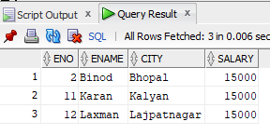SELECT * FROM Empl;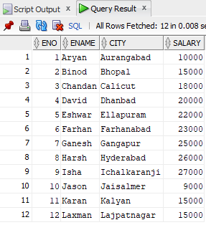

--3. Find the Employee’s name and city where Employee salary is between 15000 to 25000.

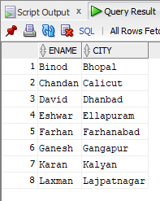SELECT ename, city

FROM Empl

WHERE salary BETWEEN 15000 AND 25000;

--4. Find the Employee’s name and city where Employee salary is between 15000 to 25000.

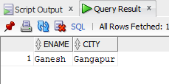SELECT ename, city FROM Empl WHERE eno = 7;

**--Horizontal Fragmentation:**

--Divide emp into horizontal fragments using the condition that emph1 contains the tuples with salary<=15000 and emph2 with salary>15000.

CREATE TABLE hfrag1 AS (SELECT * FROM empl WHERE salary <= 15000);

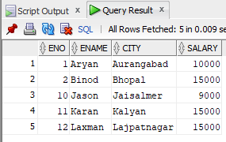SELECT * FROM hfrag1;

CREATE TABLE hfrag1 AS (SELECT * FROM empl WHERE salary <= 15000);

SELECT * FROM hfrag1;

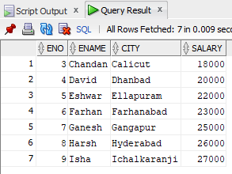

**--Vertical Fragmentation:**

--Divide emp into vertical fragments using the condition that empv1 contains the attributes (eno, ename) and empv2 contains the attributes (eno, city, salary)

CREATE TABLE vfrag1 AS (SELECT eno, ename FROM empl WHERE salary > 15000);

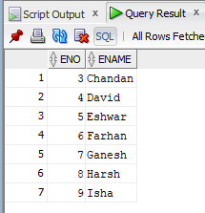SELECT * FROM vfrag1;

CREATE TABLE vfrag2 AS (SELECT eno, city, salary FROM empl WHERE salary > 15000);

SELECT * FROM vfrag2;

